<INTRODUCTION TO DATA MANAGEMENT>
PROJECT REPORT
(Project Semester January-April 2025)

(SALES OF FERTILIZERS DASHBOARD)

Submitted by
D. Jaswanth kumar

Registration No 12313722
Roll number: 17

Section K23GS
Course Code INT217

Under the Guidance of

Baljinder Kaur

Discipline of CSE/IT

Lovely School of Computer Science & Engineering

Lovely Professional University, Phagwara

CERTIFICATE

This is to certify that D.Jaswanth kumar bearing Registration no.12313722 has completed .INT217 project titled, “SALES OF FERTILIZERS Dashboard” under my guidance and supervision. To the best of my knowledge, the present work is the result of his/her original development, effort and study.

Signature and Name of the Supervisor
Designation of the Supervisor
School of Computer science & Engineering
Lovely Professional University
Phagwara, Punjab.

Date: 13 April 2025

DECLARATION

I am JASWANTH KUMAR, student of Computer science & engineering under CSE/IT Discipline at, Lovely Professional University, Punjab, hereby declare that all the information furnished in this project report is based on my own intensive work and is genuine.

Date: 13 April 2025 Signature
Registration No. 12313722 Name of the student Jaswanth

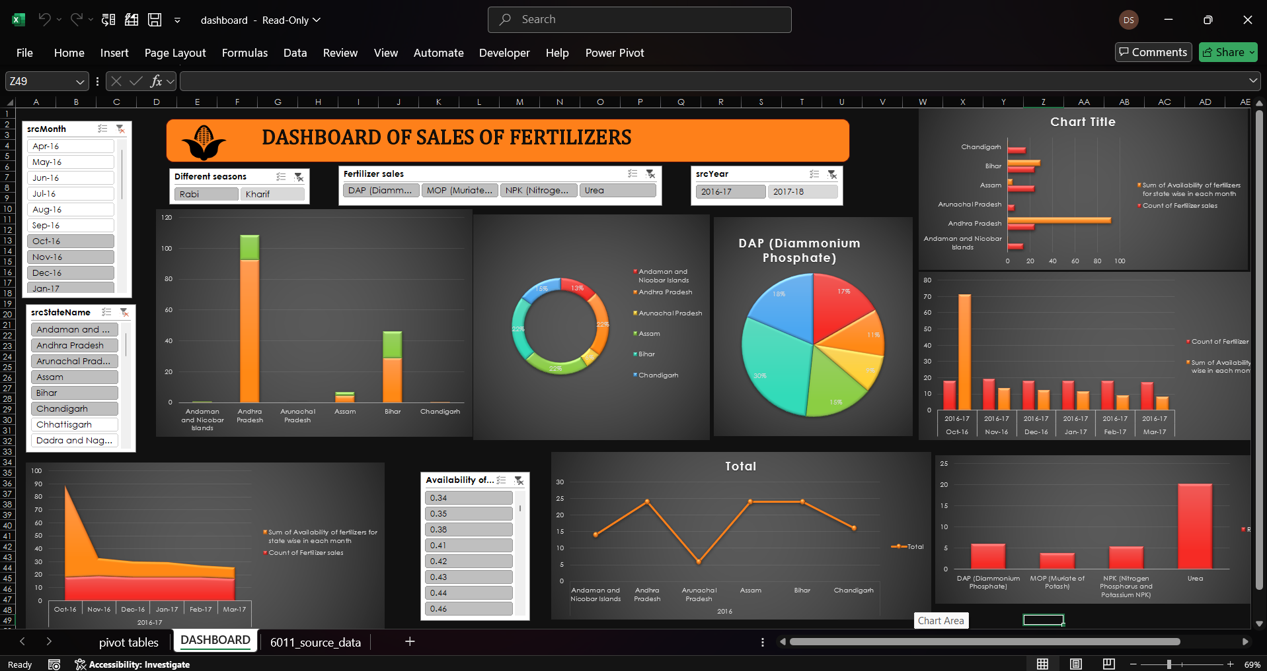
Objectives
objectives ARE Tracking Fertilizer Availability and Sales, Seasonal Analysis of Fertilizer Demand, State-wise Distribution Analysis, Yearly and Monthly Comparison, Impact Assessment of Policies or Climate Changes, Identification of Fertilizer Usage Patterns, State-wise Agricultural Insights, Supply Chain Optimization, Market Trend Analysis

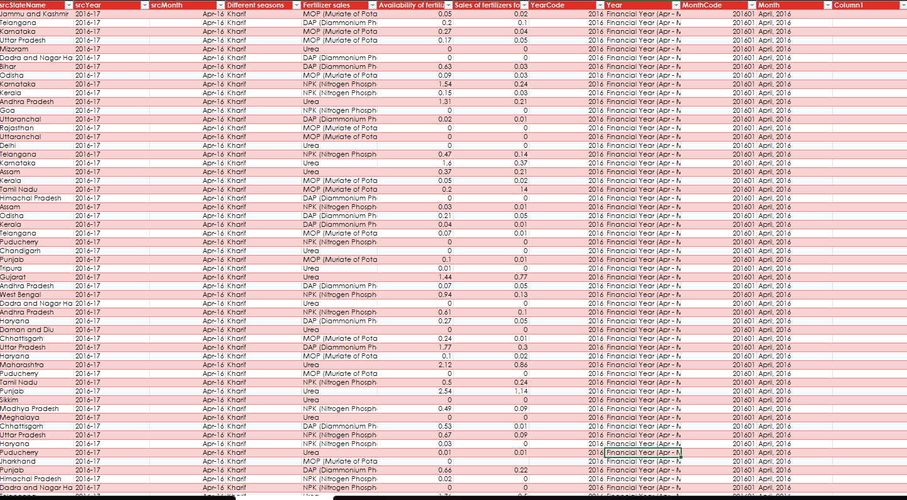
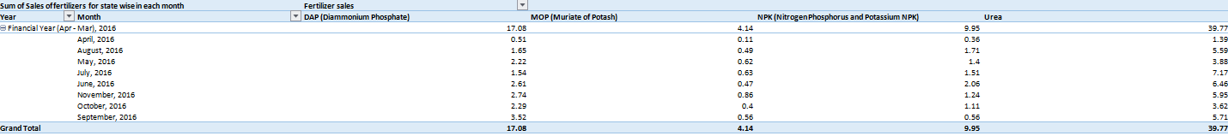

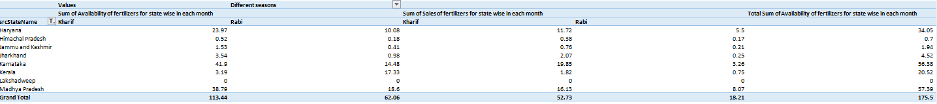

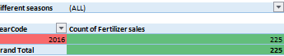

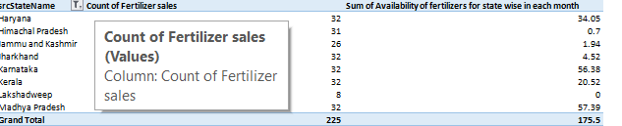

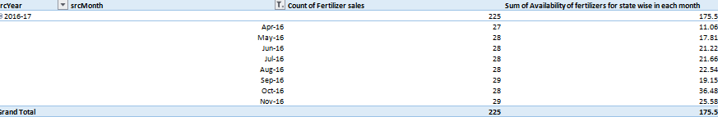

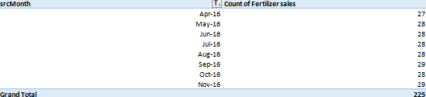

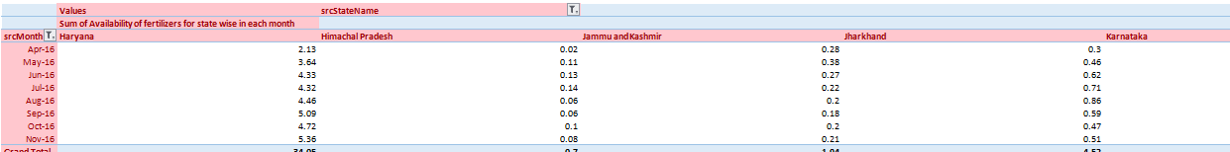

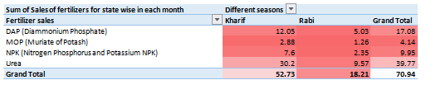

LinkedIn post
